Parallel Programming

Peyman Shobeiri

ID: 40327586

Fall 2024

Table of Contents

Question 1 3

a) 3

b) 3

Question 2 5

Question 3 5

a) 6

b) Yes, the efficiency and speed can be improved by using a block-cyclic mapping. Here, the columns are distributed cyclically among the processors: processor P0 gets columns 0, 3, and 6, processor P1 gets columns 1, 4, and 7, and processor P2 gets columns 2, 5, and 8. In this way, during the early diagonals, all processors are computing and therefore have less idle time. In the case of n = 9, the computation times for the diagonals are now more evenly distributed among the processors and are calculated like this: 7

Question 4 7

References: 9

# Question 1

**Q.1. [20 marks] In the context of parallel search techniques for discrete optimization problems, consider the *distributed tree search* scheme in which processors are allocated to different parts of the search tree dynamically as follows: initially all processors are assigned to the root. When the root node is expanded (by one of the processors assigned to it), disjoint subsets of processors at the root are assigned to each child node based on a processor-allocation strategy. One such possible strategy is to divide the processors equally among the child nodes. This process continues until there is only one processor assigned to a node; at this time the processor searches the tree rooted at the node sequentially. If a processor finish searching the search tree rooted at the node, it is reassigned to its parent node. If the parent has other child nodes still being unexplored, then this processor is allocated to one of them. Otherwise, the processor is assigned to its parent. This process continues until the entire tree is searched. Answer the following questions: (a) What is (are) the advantage(s) of this scheme? (b) Can it cause load imbalance? Explain your answer. If your answer is “yes”, give a modified scheme to fix it.**

a) Advantages of the Scheme:

1. This scheme allows the searching of several subtrees simultaneously when processors are reassigned. This can speed up the search process.

2. The scheme is easy to implement as the processors can be allocated easily without much overhead.

3. The scheme guarantees that all nodes in the search tree will be traversed. This reduces the possibility of a part of the search space being missed.

b) Yes, this scheme can lead to load imbalance based on the following reasons:

1. In scenarios where the tree is imbalanced, certain subtrees may require much more processing time than others. For example, if a parent node has four child nodes, and two of them require extensive computation while the other two finish quickly, the processors assigned to the completed nodes will become idle.
2. Processors that complete their tasks early cannot be reallocated to assist other busy processors. This results in inefficiency and idle resources.
3. Many processors remain idle during the initial early stages of the tree because there are limited parallelization opportunities.

In order to handle the problem of load imbalance, dynamic load balancing techniques can be used. In this technique, extra work from an overloaded processor is given to an idle processor. For instance:

* When one processor finishes its job, it asks for more work from other processors that are heavily loaded.

The figure below shows how dynamic load balancing works. A processor that has completed its work requests some work from another busy processor, enabling computational tasks to be more evenly distributed throughout the system. This approach helps to achieve better workload distribution and reduces idle time for processors, improving overall efficiency.

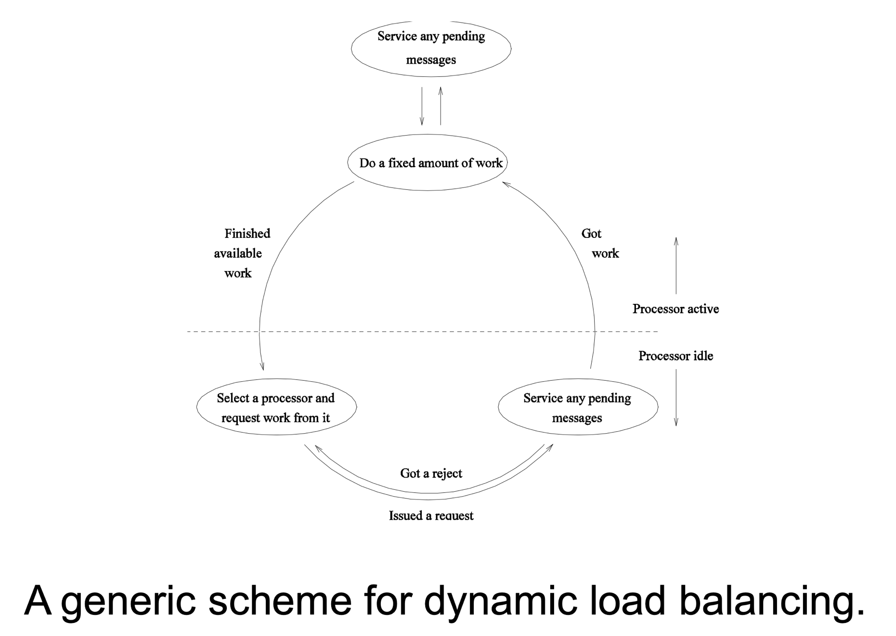

# Question 2

**Q.2. [20 marks] Prove that the *modified Diskstra’s token-based termination detection algorithm*, discussed in the context of dynamic load balancing in parallel search for discrete optimization problems (chapter 11.4.4 of textbook and the slides) is correct, i.e., the token initiator processor receives a green colored token if and only if all other processors have terminated; moreover, if the initiator processor is idle when it receives a green token, then termination is signaled.**

In the modified Dijkstra’s token-based termination detection algorithm, we can summarize that if the initiator receives a green token, then all processors have completed their work. Also, it can be stated that unless all processors have finished their tasks, the final token will not be green. Therefore, if the initiator is idle and receives a green token, the algorithm is complete.

In this algorithm, when a processor is idle, processor P0 detects termination by making itself green and passing a green token to P1. If P1 is green, it will then pass the green token to P2, and so on. However, if it encounters a red processor Pi, after Pi completes its work, it sends a red token back and makes itself green again. Since the token is red, the process must be repeated.

We can prove this by the contradiction method. Let's assume that the initiator receives a green token, but at least one processor has not completed its work. Let’s call this processor Px, which has not finished its tasks, while the token was passed as green. Since Px is not idle, it can't release a token unless it has become idle. This is our first contradiction.

Moreover, consider the scenario where Px went idle and released a green token, after which it was assigned more work by another processor, Pn. In this case, we can be sure that all processors with IDs less than n (those with ranks lower than Pn) must have become idle and sent out their green tokens. Therefore, the processor that assigned the work to Px must indeed be a processor with an ID rank greater than n, meaning it has not yet received the token. Accordingly, we can conclude that Pn will have a red color token. Consequently, a red token will reach the initiator. This contradicts our initial assumption of receiving a green token.

Therefore, with the contradiction method, we can say that our initial assumption was false, and we were able to verify the proof.

# Question 3

**Q.3. [20 marks] For the parallel formulation of the longest common subsequence problem (section 12.3.1 from textbook and the slides), as we discussed in class the maximum efficiency is upper bounded by 0.5 for very large n. Now consider the case for a small n, say n = 9, and a coarse-grained solution where more columns are mapped per processor. Answer the following questions: (a) considering n = 9 and number of processors, p = 3, calculate the maximum possible speedup and corresponding efficiency when block mapping is used (i.e. processor P0 is mapped columns 0, 1, and 2; P1 is mapped columns 3, 4, and 5; and so on). (b) Can the maximum efficiency (and speedup) be improved by using a different mapping? If your answer is “yes”, then illustrate and explain for the case: n = 9 and p = 3.**

In the serial implementation of the longest common subsequence problem, we work with an n $×$ m matrix. Since it takes constant time to process each entry in the matrix, the time complexity is given by O(nm). In this case, n = m so the time complexity is O(n2).

In the parallel implementation, processing an entry F[i,j] requires either the value of F[i-1,j-1] or the value of F[i,j-1] from the processing element to its left.  Each processing element must communicate with its nearest neighbors, resulting in a communication overhead of ts + tw, where ts is the startup time and tw is the per-word transfer time. Additionally, the computation time for each element will be tc. The processing takes place in a diagonal fashion, so the total number of iterations will be 2n – 1, where n is one side of the n $×$ n matrix. A processing element will be computing an entry on the diagonal. So, the efficiency will be:

Efficiency = $\frac{n^{2} × t_{c}}{p\left(2n-1\right)(t_{s}+t_{w}+t_{c})}$

Here, p is number of processors. If we assume that it is possible to communicate values between processing elements instantaneously, then $t_{s}=t_{w}$ = 0.

E = $\frac{n^{2}}{p\left(2n-1\right) }$

a) When block mapping is used, size of matrix is 9 x 9 = 81 and number of processors is 3. So, mapping will be done like this:

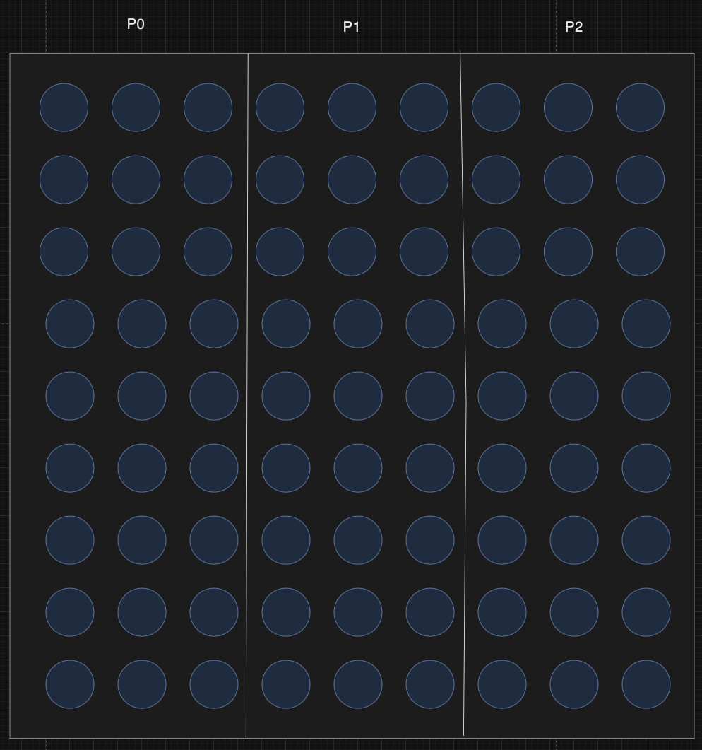

Each processor computes all entries for its assigned columns. For a diagonal with k elements, the processors work sequentially, with P0, P1, and P2 each handling k/p elements. With this distribution, we calculate efficiency as follows:

E = $\frac{n^{2} × t_{c}}{ p × Tp}$

The total parallel execution time involves summing the computation times across all diagonals. When n = 9, there are a total of 2n -1 = 17 diagonals. Suppose ts = tw = 0, then the computation time for each diagonal in terms of tc is:

Tp = 11 + 17 + 17 = 45

S = 81/45 = 1.8

This simplifies to:

E = $\frac{81×t_{c}}{ 3×45{×t}_{c}}$ = 0.6

## b) Yes, the efficiency and speed can be improved by using a block-cyclic mapping. Here, the columns are distributed cyclically among the processors: processor P0 gets columns 0, 3, and 6, processor P1 gets columns 1, 4, and 7, and processor P2 gets columns 2, 5, and 8. In this way, during the early diagonals, all processors are computing and therefore have less idle time. In the case of n = 9, the computation times for the diagonals are now more evenly distributed among the processors and are calculated like this:

Tp = 35

S = 81/35 = 2.31

So, we have:

E = $\frac{81×t_{c}}{ 3×35{×t}_{c}}$ = 0.77

# Question 4

**Q.4. [20 marks] Consider the following program (Note: *Si* represents statement i):**

**S1: a = b + c;**

**S2: ....**

**....**

**Sn: ....**

**for (int i = 0; i < m; i++) {**

**Sn+1: x[i] = c + d;**

**Sn+2: ....**

**....COMP 428/6281 – Fall 2024**

**Assignment 3 – page 2 of 2**

**Sn+20: ....**

**}**

**Referring to the above program, statements *S1* through *Sn+1* must execute in sequence due to data dependencies among themselves. In each iteration of the loop, there is dependency between every pair of alternate statements, i.e., there is data dependency between statements *Sn+j* and *Sn+j+2*, 1 ≤ j ≤ 18. However, there are no loop carried dependencies among different iterations of the loop. Assume that each statement takes equal amount of time to execute and there are no additional overheads. The program is automatically parallelized. For a given *n* and *m*, what is the maximum possible speedup**

**SMax? Show your calculations.**

The program begins with a sequence of statements S1 through Sn, followed by Sn+1. All statements need to be performed sequentially because of the data dependency among them. The result of one statement becomes an input for another. There is no parallelization in this part.

After the sequential statements, a loop iterates m times. In every iteration, there are 20 statements, namely Sn+1 to Sn+20. In every iteration, between every pair of alternate statements, there is a data dependence: more precisely, statement Sn+j depends on Sn+j-2 for 3 <= j <=20. That means not all statements within an iteration can run in parallel due to intra-iteration dependencies.

However, it is important to note that there are no loop-carried dependencies among different iterations of the loop. This is a crucial point, as it implies that iterations of the loop are independent of each other and can be executed in parallel. So, this loop is a good candidate for parallelization.

To compute the total sequential execution time, we could consider the time it takes to execute all statements without utilizing parallelism. Each statement takes an equal amount of time t to execute. The sequential portion before the loop consists of n + 1 statements (S1 to Sn+1), while the loop contains 20 statements per iteration, resulting in a total of 20m statements for m iterations. Therefore, the total sequential execution time is expressed as:

Ts= (n + 1 + 20m) $×$ t

For the parallel execution time, it is recognizable that the initial sequential statements S1 to Sn+1 still need to be executed sequentially, which takes (n + 1) $×$ t time. However, the loop iterations can be executed in parallel since there are no dependencies between them.

Within each loop iteration, due to the dependencies between alternate statements, the statements form two independent chains:

1. Chain A: Consists of statements Sn+1, Sn+3,…, Sn+19

2. Chain B: Consists of statements Sn+2, Sn+4,…, Sn+20

Each chain contains 10 statements, and within a chain, the statements must be executed sequentially because of the dependencies. However, since the two chains are independent of each other, they can be executed in parallel within the iteration. Consequently, the critical path length for each iteration is the time taken to execute the longest chain, which is 10 $×$ t.

Since all loop iterations are independent and can be executed simultaneously, the total time to execute all iterations in parallel equals the time to execute one iteration's critical path. Therefore, the total parallel execution time is:

Tp= (n + 1) $×$ t + 10 $×$ t = (n + 11) $×$ t

Finally, the maximum possible speedup is calculated by dividing the total sequential execution time by the total parallel execution time:

Smax= Ts / Tp = (n + 1 + 20m) $×$ t} / (n + 11) $×$ t = n + 1 + 20m / n + 11

# References:

[1]: Grama et al, 2003, Introduction to parallel computing second edition